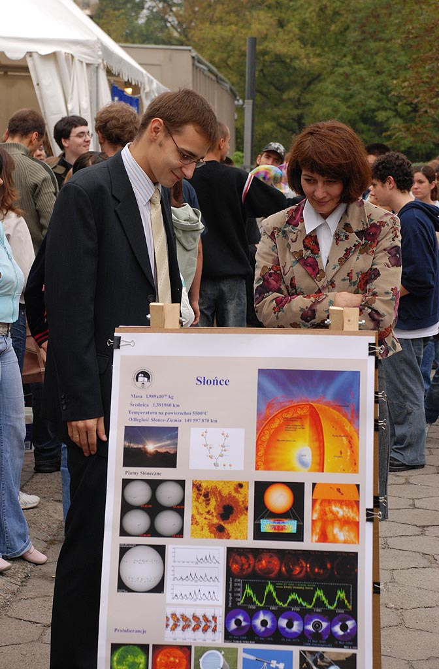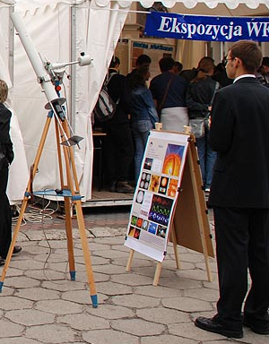

A series of single page PowerPoint posters was prepared to print it at A1 format. It can be useful for public presentation of the sky and help to oral presentation of several objects. Speaker use pictures during talk in different orders and different level o difficulties. During one show one can use two posters together (for example “The Sun” and “the solar eclipse, “Moon” and “Moon eclipse”, etc). Posters can be presented at any walls but better way is simple wooden construction staying near the telescope
Same ephemeredes (eclipse timing, Jupiter’s moons positions etc) can covered by an up-to-date printed data in A4 format.

http://www.as.ap.krakow.pl/edu/ppt/e-sun.ppt Sun 2 MB
http://www.as.ap.krakow.pl/edu/ppt/e-sunecl.ppt Solar eclipse 3 MB
http://www.as.ap.krakow.pl/edu/ppt/e-moon.ppt Moon 5 MB
http://www.as.ap.krakow.pl/edu/ppt/e-moonecl.ppt Moon's eclipse 5 MB
http://www.as.ap.krakow.pl/edu/ppt/e-mars.ppt Mars 16 MB
http://www.as.ap.krakow.pl/edu/ppt/e-jupiter.ppt Jupiter 3 MB
http://www.as.ap.krakow.pl/edu/ppt/e-saturn.ppt Saturn 4 MB
http://www.as.ap.krakow.pl/edu/ppt/e-nebula.ppt Nebulas 25 MB

SUN

- Sun over the clouds
- Source of solar power
- Solar structure
- Solar rotation
- Structure of solar spots
- Gas temperature and magnetic filed in the sunspot
- Solar surface in different wavelengths (sunspots position is correlated with magnetic loops)
- Solar rotation
- Solar cycles (Wolf numbers)
- Butterfly diagram
- Correlation between wolf number, magnetic field and solar corona (red and blue dots on Wolf number curve corresponding to images of sun from top and bottom panel
- , 13, 17, 18 Solar prominences in different wavelengths
- Mylar filter used before objective
- Scheme of projections method
- Picture of solar image

Solar eclipse;

- Satellite picture of Moon’s shadow
- Sun, Moon and Earth position during different types of eclipses
- 2000-2025 eclipses path
- – 7. Partial eclipses in different phases
8 . Mosaic picture of total eclipse
9. Total eclipse (Corona, prominences, flares etc)
10. Solar corona
11. Bailey’s beads
12. Diamond ring effect
13. – 14. Annular eclipses
15. Annular eclipse step by step
16. Eclipse time table (for update see: http://sunearth.gsfc.nasa.gov/eclipse/eclipse.html
Moon

- Moon Map
- Far side of moon
- Historic picture of far side of moon (Luna 3)
- A man no the moon
- 2-3 after new moon. Part of moon’s surface is illuminated by solar light reflected by Earth
- First step of human out of Earth
7.-8. Schematic view of moon’s phases
9.-10. Moon in different phases,
11. Simple map of Moon for binocular and small telescope observations
12. Earth and Moon in the same scale
13. Panoramic view of Apollo expedition to Fra Mauro crater.
14. Copernicus
Examples of moon’s surface structure: crater’s central hills, old and young surface, different carter density, flat carter’s bottom because of magma outflow etc.

a) Eratosthenes
b) Gassendi
c) Hadley Rille
d) Theophilus
e) Alpine Valley
f) Atlas and Hercules
g) Straight Wall
h) Ptolemaeus and Alphonsus
i) Aristarchus
j) Plato
k) Clavius
l) Walter

15. Example of moon’s libration. For explanation that we can see more than 50% of Moon

Lunar Eclipse

- Moon’s orbit inclination, nodes etc..
- Why we see moon’s surface during total eclipse in red color?
- Umbra and penumbra zones, orbit of Moon
- Total eclipse
- Partial eclipse
- Partial eclipse (shadow of Earth)
- Almost total eclipse
- – 10. Mosaic picture of eclipse
11. - 12. Earth shadow
13. Eclipse time table
(One can replace it by new data from: http://sunearth.gsfc.nasa.gov/eclipse/eclipse.html)

Mars

  - Earth and Mars
  - Oppositions of Mars (what is opposition, distance from Earth to Mars, etc ….)
  - Martian loops
  - Image of Mars and old map of surface
  - Panoramic view of surface
  - Panoramic view of surface
  - Mosaic map of Mars, (Olympus Mons, mariner Valley, etc)
  - Deimos
  - Phobos
  - Weather on Mars (Dust storm)
  - Spirit
  - Olympus Mons
  - – 15. Water on Mars

Jupiter

- Opposition and conjunction
- HST image of Jupiter (belts of clouds, spots, etc)
- Positions of moons, It could be covered by recent data from: http://www.as.ap.krakow.pl/pl-ascii/ac.html#jme
- Scheme of Jovian moons orbit with Earth and Sun positions, shadow zone etc. Useful for events explanations
- Voyager picture showing Jovian belt
- Io, Europa, Ganimedes, Calisto
- Draw of Jupiter’s using small telescope, (clouds, belts, spots etc)
- Names of major belts of clouds
- Giant red spot compare with Earth size
- Giant red spot
- Inner structure
- Belts of clouds

Saturn

- Saturn’s satellites
- Schematic positions of satellites and rings inclination. One can over this diagram by up-to-date image from http://www.as.ap.krakow.pl/pl-ascii/ac.html#jme
- Sizes of rings and satellite’s orbit
- Small telescope view
- Ring inclination is changing in 15 years cycle
- Artistic view of ring’s structure
- Saturn’s family
- – 12. Rings (useful for describing ring structure, thickness, transparency, etc
- Earth size as an comparison for Saturn globe and rings

Fuzzy Objects

- Charles Messier
- Messier objects
- Draw of M57 (This is what one can see using small telescope)
- Long expose CCD image of M57 is different than small scope view
- M1 Crab nebula (Another type of gas object)
- Horse Head (composition of bright and dark clouds of dust and gas)
- dark nebula (coal sack)
- Bright Nebula (M42 in Orion)
- Young star cluster Pleiades and rest of gas nebula
- M13 globular star cluster (example of nebular object composed from stars)
- Andromeda galaxy –
- Schematic view of Milky Way (for explanation the difference of sizes and structure of different type of nebular objects)
- All sky mosaic picture of Milky Way
- Schematic view of our galaxy from top and position of Sun
- Large Magellan Cloud (irregular)
- Small Magellan Cloud – satellites of Milky Way (irregular )
- Local group of galaxies
- Virgo cluster of galaxies (and view from small telescope)
- Different types of spiral galaxies
- M81 and M82

