The Event Depicted on VMs Folio 68r1
By Robert Teague
7 March 2012

Folio 68r1 is part of a three-panel foldout in the Astronomical/Cosmological section of the Voynich Manuscript. At first glance, it seems to represent the sun and moon on opposite sides of a field of labeled stars.

I have never agreed with that interpretation, as the sunlit crescent of the moon faces 90° to the left of the “sun”. If the upper object is the sun, why isn’t the lit edge pointing toward it? The face on the moon is rather generic, while the face on the “sun” is more detailed, possibly a real person. To me, the overall “feel” of the folio is that it shows a real event. This paper offers an interpretation and supporting evidence.

If the upper object is not the sun, what could it be? My first thought was a comet. If so, the face could be someone connected to it. But which comet and what person?

Investigation would have to wait until one or more star labels were cracked, to identify what area of the sky it is. A clue is actually given by the split nature of the Taurus and Aries folios in the Zodiac section. Research has shown there is more symbolism in those signs than in any others, indicating their importance or significance to the Author.

The first label cracked is on the bottom, to the right of the moon; #29 in the very useful Voy-101 transcription. The label is translated as Aldebaran. (Discussion of my label work is beyond the scope of this paper.)

This provided a place in the sky and orientation along with a time of year, as the waning crescent moon is seen near Aldebaran only in late June, July and August.

The 15th and 16th century comet orbital data provided in Gary W. Kronk’s online Cometography was added to Starry Night Pro 4, a planetarium program. With a viewing location set for London, England, runs were made to determine candidate comets, with success.

Only one comet appeared in the correct position; north of a waning crescent moon to the left of Aldebaran. The folio appears to depict a comet, moon, and star field as seen on 18 July 1533. The moon had occluded Aldebaran 24 hours earlier.

This has led to the identification of many of the stars, and aided in the cracking of the labels. As of this writing, only 6 of 29 remain unknown.

Additional evidence was found in Petrus Apian’s Astronomicum Caesarium 1540, which includes study of the 1533 comet. A diagram of the comet’s movement, drawn from Ingolstadt, Germany is on page 118 of the PDF.
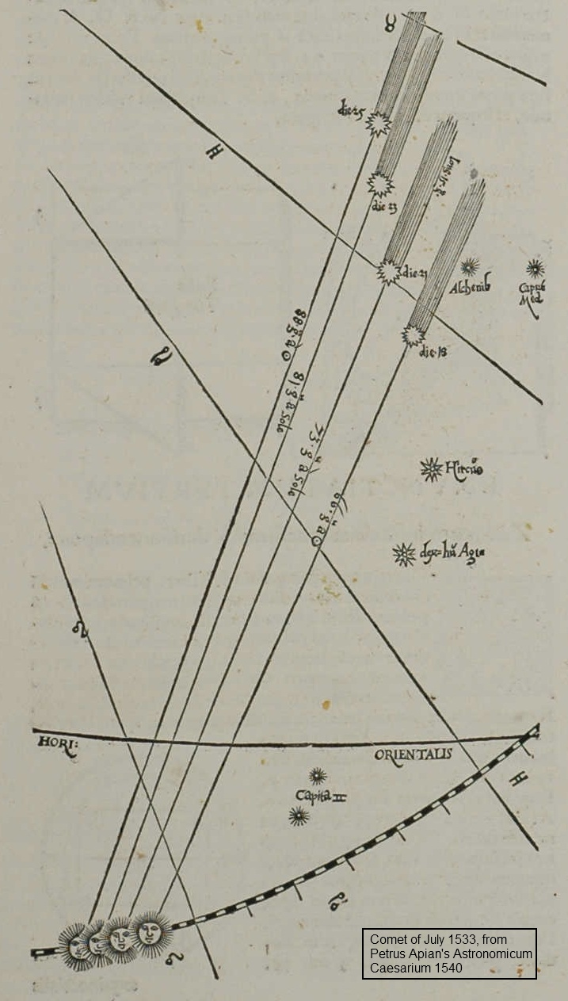
The art program Paint.NET has the capability of adjusting the transparency of a picture and making an overlay with another.

A crop of f68r1 was made from the .sid format file, and converted to .jpg. The diagram above was cropped and converted, then overlaid on the folio, adjusting angle and size to produce the best fit.

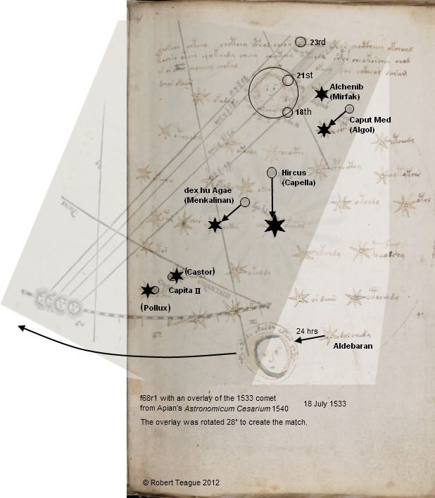

The folio includes the moon and comet, while the diagram includes the sun and comet. The lit crescent of the moon faces the sun, as it should.

Both share the same six stars, of which three match by position, while two are offset by the same angle and amount, and the last shifted, possibly for artistic reasons. All three remain correct in relation to other stars.

The labels of the six stars had been cracked prior to making the overlay, and all were identified correctly.

A star chart of the event was made with Starry Night Pro 4. As Ingolstadt is not an available viewing location, Munich, Germany, to the south, was used. The elements of the overlay were added or marked, and everything lines up as it should. In addition to confirming the orientation of the moon, its path south of the sun’s is correct.

The event was observed by the VMs Author from a different location, as the overlay angle indicates, and somewhat later in the morning, as the folio included the moon, Castor and Pollux.
These had not risen in the diagram.

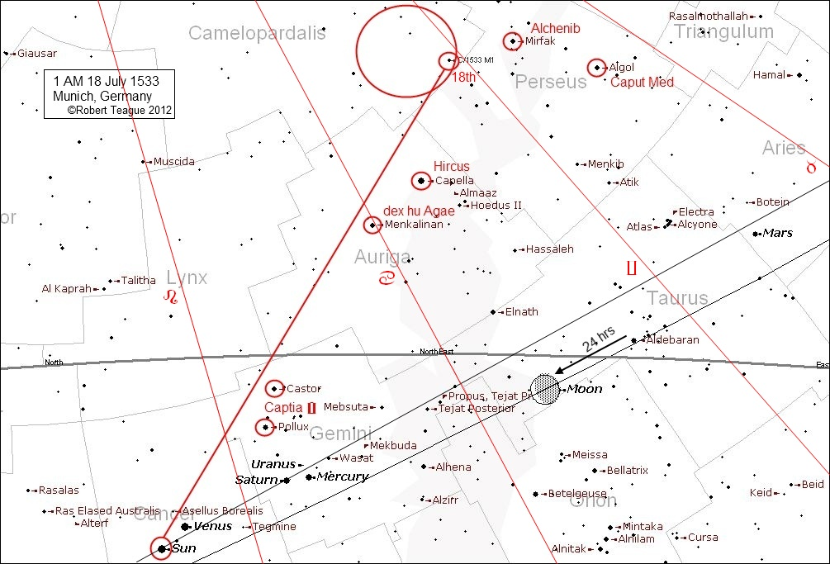

The person depicted in the comet is suspected to be Nicolai Copernicus, who wrote a treatise on it which is apparently now lost.

A drawing of Copernicus which appears to be the one used as a template was found online, and a crop of the comet made. The former was overlaid on the latter, and the size shifted to create a match. It was discovered that when the outline of the head and hair matched, the facial features didn’t, and vice versa. The words in the circle have been translated as “NK London England”.

Animated gifs were made of both configurations, and below are frames from each. Both are available as single compressed .rar file.

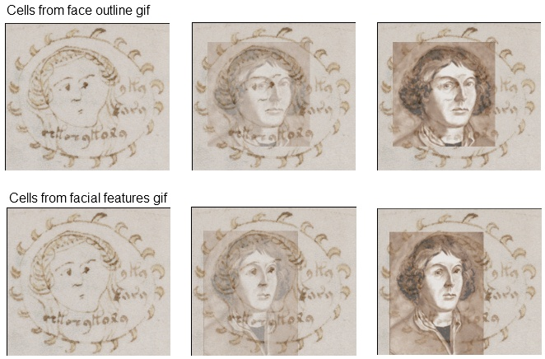

The stars common to both the folio and the diagram have been identified:

No. | Folio | Diagram | Modern
1 | Algeneb | Alchenib | Mirfak
6 | Ras (al Ghul) | Caput Med(usa) | Algol
15 | (Men)kali(nan) | dex(ter) hu(merus) A(uri)gae* | Menkalinan
16 | Capella | Hircus | Capella
 |  | Capita Gemini
20 | (Ras) al Taum |  | Castor
24 | Ras (al Jauza) |  | Pollux
*thanks to Greg Stachowski for the translation

Conclusion

It is proposed that Voynich Manuscript folio 68r1 depicts a comet seen on 18 July 1533, and includes a picture of Copernicus.

The material offered in this paper is not conclusive proof of the proposed meaning, but I do feel it is strong evidence in favor of it.

