DISCUSSION OF THE PLANT ILLUSTRATED IN FOLIO f9V OF THE VOYNICH MANUSCRIPT

The plant in folio f9v in the Voynich Manuscript has been most often compared to the Viola and more specifically “Viola Trinitas/Tricolor” (Petersen, 1931), also known as the “Wild Pansy” or “Heartsease”. Morphologically it is the most easily and reliably identified of all the plants in the manuscript, yet there are some issues that the view of many that the plants are either fantastical or images drawn from memory and certainly cannot be considered botanically accurate. I do not agree with this view and suggest the plant on f9v is without doubt a Viola and that it was copied from an actual specimen, though probably not by a botanist. The plant from the Voynich Manuscript (fig. 1.) is compared to a botanical image of Viola Tricolor (fig. 2.) below, the morphology in all its gross components can be seen to be accurate.

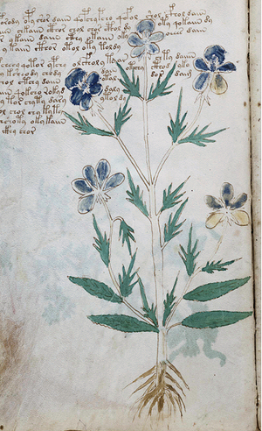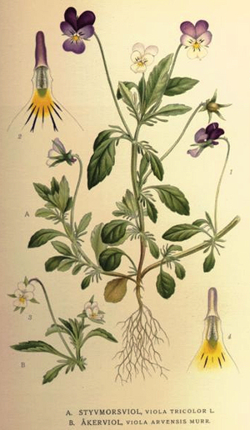
Fig. 2. Viola tricolor styvmorsviol from Projekt Runeberg: Bilder ur Nordens Flora. PD image. Source: Wikimedia Commons.

Fig. 1. f9v. Voynich Manuscript. Credit: Beinecke Rare Book and Manuscript Library, Yale University.

I have used a common garden Pansy as shown below (fig. 3.) for comparison in discussing the disputed attributes of the plant, more specifically in relation to the flower heads.

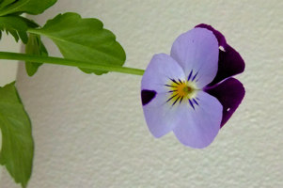
Fig. 3. Pansy. P. Han

The flower heads of the top flowers on f9v appear to be quite accurate, the perianth consisting of five petals of the corolla, four separate fan shaped petals and one broad, lobed petal that points away from the fan, in life this broad petal is seen pointing downwards. Below the petals there is what appears to be the calyx drawn and the petals are spread away from the stem. I suggest that the apparent upside down flower heads shown in f9v of the manuscript is consistent with the plant being spread flat prior to drawing, either deliberately or as a result of the plant having been preserved in that position. This detail is consistent with the image having been drawn from a real specimen rather than imagined and certainly if drawn from memory or life the petals would have been drawn in the correct orientation. In the images below next to that from the manuscript, it can be seen that the presentation of the Pansy in this way is almost identical to that presented in the manuscript and if the lower petals in this orientation were spread away from the stem it could possibly reveal the lower sepals at the back of the flower head and maybe the petals on the flower head in the manuscript were placed in this manner to show this feature.

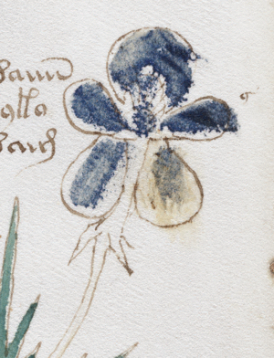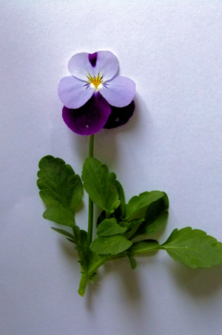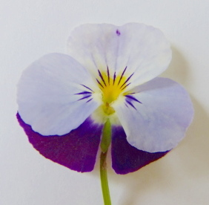
Fig. 4. f9v.cropped, showing upper right flower head. Voynich Manuscript. Credit: Beinecke Rare Book and Manuscript Library, Yale University.
Fig. 5. Pansy shown from front with stem straightened. P. Han.

Fig. 6. Close up of Pansy shown from front with stem straightened and petals parted to reveal sepals. P. Han.

The central details of the flower head shown from f9v (fig. 7.) appears to be consistent with the front view of the flower rather than a back view, with an attempt to show the stamens or a central variation of colour structure as sometimes seen (fig. 8.).

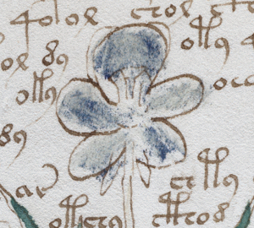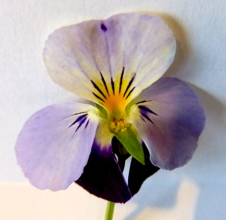
Fig. 7. f9v.cropped, showing upper central flower head. Voynich Manuscript. Credit: Beinecke Rare Book and Manuscript Library, Yale University.

Fig. 8. Pansy shown from front with stem straightened, stamen and lower sepals exposed. P. Han.

The flower heads of the two lower flowers on f9v appear to be quite accurate for a back view of the flower heads of Viola (figs. 10, 11.) The perianth is shown fully detailed, the five petals of the corolla are accompanied by the sepals of the calyx with the stem joining centrally to the calyx. The flower head on the bottom left of f9v (fig. 9.) is shown with the correct number of sepals which should number five, the one on the left is shown with six which may be confusion with a lower part of one of the sepals. The inferior petal is shown too narrow but those of the front orientation examples are shown correctly, suggesting that the presence of the calyx was the important detail to present in this orientation and the number of petals is still correct.

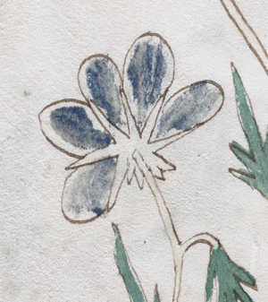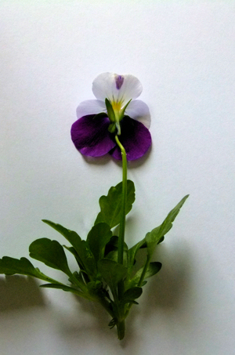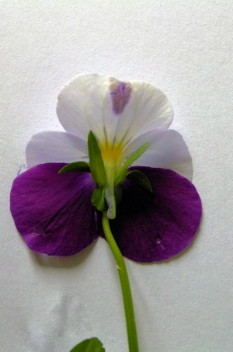
Fig. 9. f9v. cropped showing lower left flower head. Voynich Manuscript. Credit: Beinecke Rare Book and Manuscript Library, Yale University.
Fig. 10. Pansy shown from back with stem straightened, calyx shown. P. Han.
Fig. 11. Close up of Pansy shown from back with stem straightened, calyx shown. P. Han.

Overall, I suggest the image in the Voynich Manuscript is consistent with an artist who is not a botanist working from a real specimen which may be dried, pressed or fresh but wilted and arranged in such a way that the stems are straightened inverting the natural presentation of the flower head as seen in life, the damage of the missing leaves and shortened root hairs is more suggestive of an older specimen. The colouration of the petals is consistent with some types of Viola although many colour variations are possible, and the writing present on some of the petals suggest the colours were indeed faded or passed on to another for colouration, though remain true to type. The distribution of the colour marking (differing letters/words) is consistent with the top petals being of differing colour to the other petals as often seen in Viola. Alternatively these markings may be technical and describe the change in orientation of the petals from life, i.e., top and bottom of the flower head inverted. Discussions on the markings found on some Voynich Manuscript plants can be found here:

http://www.ciphermysteries.com/2010/02/27/letters-hidden-in-voynich-plants

http://www.ugcs.caltech.edu/~reuben/voynich/plant-writing/

The flower heads are clearly shown from front and from the back even though there is a slight error in the number of sepals on the bottom left flower head shown from the back and may be a slight inability of the artist to distinguish all the sepals from the, this in itself suggest that the artist was not a botanist who would know that the five petals of the corolla are accompanied by the five sepals of the calyx on the perianth of Viola.

The leaves shown are of the slightly elongated mature leaves of the plant compared to the more rounded jeuvenile leaves but the few leaves shown may just represent the only remaining leaves on the specimen. They are shown to be toothed and the stipules are leaf like, almost being leaves in their own right. The leaves though not shown in their entirety are fully consistent with what may be expected from an old or damaged specimen that is not fully intact.

The roots appear to be almost of the tap root type but would also be consistent with fibrous root type that had been broken on removing from the ground,
maybe just copied as seen in their damaged or dried state, or even just a little too difficult for the artist to replicate in detail.

If this plant can be demonstrated to be botanically accurate as a type of Viola then it holds out that the other plants in the manuscript may also be real and accurate. Allowing for the state of any specimens possibly being dried or old (particularly those brought from any great distance) rather than fresh and laid out in what may be an unnatural position, this may allow the remaining plants to also be considered in this light.

© 2011 P. Han

