

Observational Exam

Naked Eye Observations
Solutions and Marking Scheme

Marking Scheme: Question 1
Part 1: Location of each bright star: (max: +40)

- Small Circle + Correct Number: +10 points.
- Large Circle+ Correct Number: +5 Points.
- Small Circle without Identifier Number : +5 Points
- Large Circle without Identifier Number: No Point.
- Small or Large Circle+ Incorrect Identifier Number: No Point.

Figure 1 – Solution of Problem 1
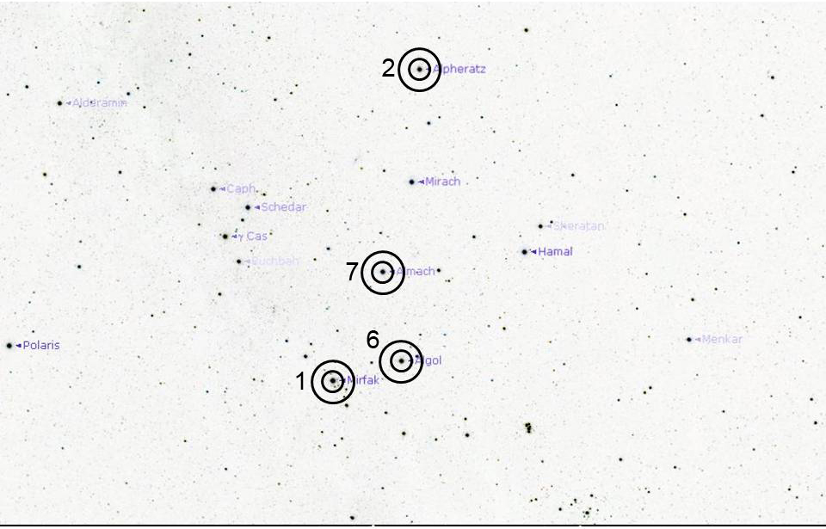

Marking Scheme: Question 2

Part 1: Angular Distance (max: 40 point)

For Each Pair:
$∆≤2^{° }$: 20 points
$2^{°}<∆≤ 4^{°}$ : 10 Points
$∆>4^{°}$ : No Point

Table A_ Solution

Angular Distance
Stars Name | Angular Distance (Degree)
1 (Errai ) and 2 (Alfirk ) | ${11}^{°}:{09}^{'}:{10}^{''}$ $\sim {11}^{°}$
1 (Errai ) and 3 (Alderamin) | ${18}^{°}:{36}^{'}:{50}^{''}$ $\sim {19}^{°}$

Part 2: Magnitude estimation for Each Star (max: 40 Point)

For Each Star:
$∆≤0.2$: 20 points
$0.2<∆≤ 0.5$ : 15 Points
$0.5<∆≤ 0.8$ : 10 Points
$0.8<∆≤ 1.0$ : 5 Points
$1.0<∆≤ 1.2$ : 2 Points
$∆>1.2$ : No Point

Table B_Solution

Magnitude Estimation
Number | Star Name | Visible Magnitude
2 | Alfirk | 3.2
3 | Alderamin | 2.4

Observational Problems

Telescopic Observations
Solutions and Marking Scheme

Marking Scheme: Question 3

Part 1: Point the Telescope to the coordinates of the selected stars. (Max: 40 points)
If the examiner confirms the star in the 32 mm eyepiece: 40 Points
If the examiner confirms the star in the finder scope: 20 Points
If the examiner doesn’t see the star in Finder : No Point

Part2: Estimate Hour Angle and Declination. (Max: 40 Points)

HA: $∆≤30 min$: 40 points
$30 min<∆≤ 45 min$ : 30 Points
$45 min<∆≤1Hour$ : 20 Points
$1 Hour<∆≤ 1.5 Hour$ : 10 Points
$∆>1.5 Hour$ : No Point

If Participant estimates R.A. Instead of H.A.: 2 Point
Dec:
$∆≤2^{° }$: 40 points
$2^{°}<∆≤ 4^{°}$ : 30 Points
$4^{°}<∆≤ 8^{°}$ : 20 Points
$8^{°}<∆≤ {10}^{°}$ : 10 Points
$∆>{10}^{°}$ : No Point

Coordinate of Selected Star |  |  |  | Local Time :
Star | Hour Angle | R.A. | Dec. | Local Time :
1- Deneb (Alpha Cygni) | ST-RA | 20h 41m 46.632s | +45°19'15.675" | Local Time :
2-Alfirk (Beta Cephei) | ST-RA | 21h 28m 47.853s | +70°36'35.254" | Sidereal Time :
3- Algol (Beta Persei) | RA-ST | 03h 08m 51.224s | +40°59'43.119" | Sidereal Time :

