Information:
Picture 1 presents a negative image of sky taken by a CCD camera attached to a telescope whose parameters are presented in the accompanying table (which is part of the FITS datafile header).
Picture 2 consists of two images: one is an enlarged view of part of Picture 1 and the second is an enlarged image of the same part of the sky taken some time later.
Picture 3 presents a sky chart which includes the region shown in the CCD images.

The stars in the images are far away and should ideally be seen as point sources. However, diffraction on the telescope aperture and the effects of atmospheric turbulence (known as 'seeing') blur the light from the stars. The brighter the star, the more of the spread-out light is visible above the level of the background sky.

Questions:

- Identify any 5 bright stars from the image and mark them on both the image and map.
- Mark the field of view of the camera on the map.
- Use this information to obtain the physical dimensions of the CCD chip in mm.
- Estimate the size of the blurring effect in arcseconds by examining the image of the star in Picture 2.
(Note that due to changes in contrast necessary for printing, the diameter of the image appears to be about 3.5 times the full width at half maximum (FWHM) of the profile of the star.)
- Compare the result with theoretical size of the diffraction disc of the telescope.
- Seeing of 1 arcsecond is often considered to indicate good conditions. Calculate the size of the star image in pixels if the atmospheric seeing was 1 arcsecond and compare it with the result from question 4.

Two objects observed moving relative to the background stars have been marked on Picture 1. The motion of one (“Object 1”) was fast enough that it left a clear trail on the image. The motion of the other (“Object 2”) is more easily seen on the enlarged image (Picture 2A)and another image taken some time later (Picture 2B).

Using the results of the first section, determine the angular velocity on the sky of both objects.

Choose which of the statements in the list below are correct, assuming that the objects are moving on circular orbits. (Points will be given for each correct answer marked and deducted for each incorrect answer marked.)

The probable causes of the different angular velocities are:
- different masses of the objects,
- different distances of the objects from Earth,
- different orbital velocities of the objects,
- different projections of the objects’ velocities,
- Object 1 orbits the Earth while Object 2 orbits the Sun.

Data:

From the FITS datafile header of Picture 1:

BITPIX = 16 / Number of bits per pixel
NAXIS = 2 / Number of axes
NAXIS1 = 1024 / Width of image
NAXIS2 = 1024 / Height of image
DATE-OBS= '2010-09-07 05:00:40.4' / Middle of exposure
TIMESYS = 'UT' / Time Scale
EXPTIME = 300.00 / Exposure time (seconds)
OBJCTRA = '22 29 20.031' / RA of center of the image
OBJCTDEC= '+07 20 00.793' / DEC of center of the image
FOCALLEN= '3.180m' / Focal length of the telescope
TELESCOP= '0.61m ' / Telescope aperture

Picture 1
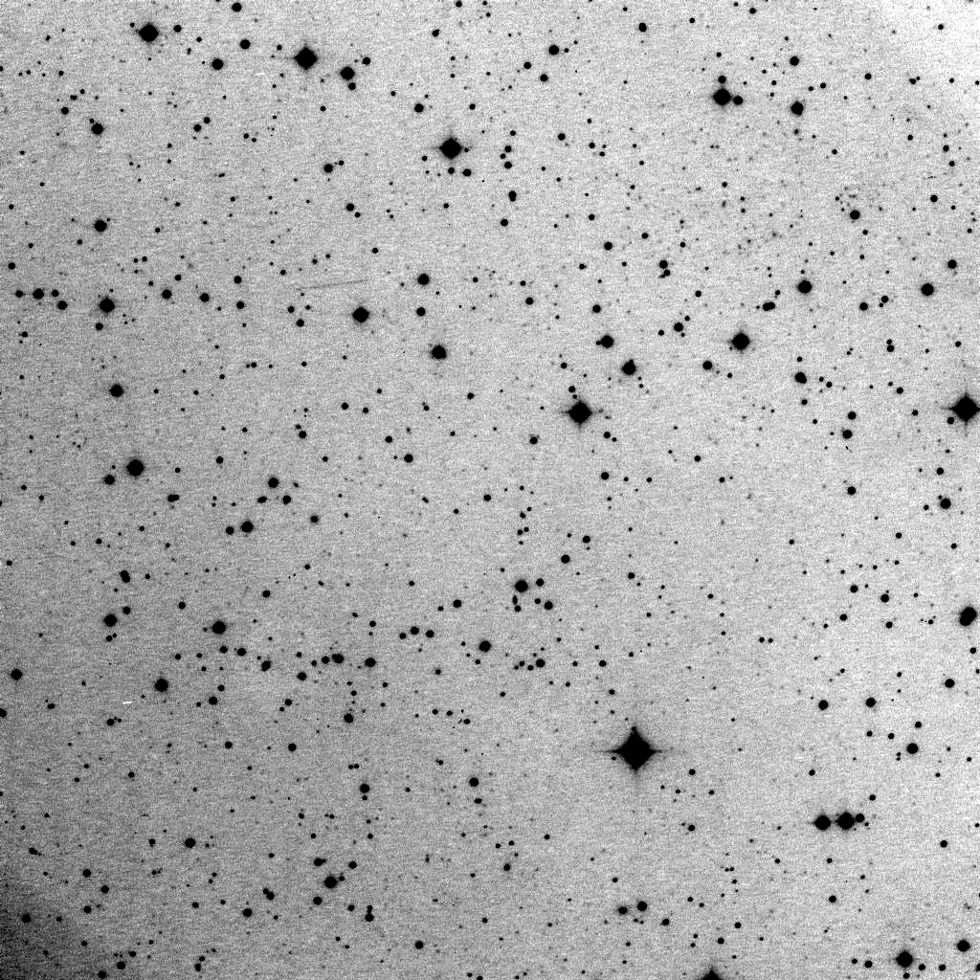
Object 1
Object 2


A B

Picture 2:
A: Enlargement of Picture 1 around Object 2,
B: The same area observed some time later. For this image the FITS header file contains instead:
DATE-OBS= '2010-09-07 04:42:33.3' / Middle of exposure
Picture 3: