Data Analysis questions
- Analysis of times of minima

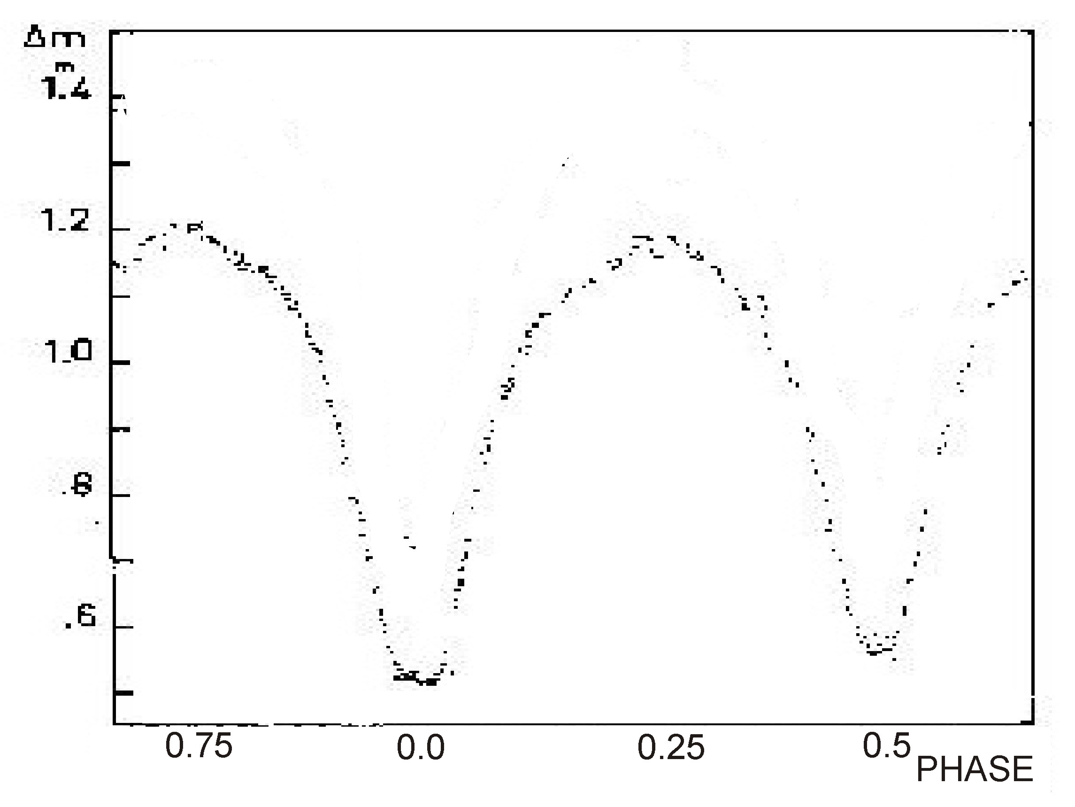Fig. 1: Light curve of V1107 Cas.
Figure 1 shows the light curve of the eclipsing binary V1107 Cas, classified as a W Ursae Majoris type.
Table 1 contains a list of observed minima of the light variation. The columns contain: the number of the minimum, the date on which the minimum was observed, the heliocentric time of minimum expressed in Julian days and an error (in fractions of a day).

Using these data:
- Determine the period of V1107 Cas, assuming that the period of the star is constant during the interval of observations.
- Make what is known as an (O−C) diagram (for “observed − calculated”) of the times of minima, as follows: on the x-axis put the number of periods elapsed (the “epoch”) since a chosen initial moment M_{o} ; on the y-axis the difference between the observed moment of minimum M_{obs} and the moment of minimum calculated using the formula (“ephemeris”):
M_{calc} = M_{o} + P × E
where E, the epoch, is exactly an integer or half-integer, and P is the period in days.
- Using this (O−C) diagram, improve the determination of the initial moment M_{o} and the period P, and estimate the errors in their values.
- Calculate the predicted times of minima of V1107 Cas for the night 1−2 September 2011. Give the result in UT.
No. | Date of minimum  (UT) | Time of minimum  (Heliocentric JD) | Error
1 | 22 December 2006 | 2 454 092.4111 | 0.0004
2 | 23 December 2006 | 2 454 092.5478 | 0.0002
3 | 23 September 2007 | 2 454 367.3284 | 0.0005
4 | 23 September 2007 | 2 454 367.4656 | 0.0005
5 | 15 October 2007 | 2 454 388.5175 | 0.0009
6 | 15 October 2007 | 2 454 388.6539 | 0.0011
7 | 26 August 2008 | 2 454 704.8561 | 0.0002
8 | 5 November 2008 | 2 454 776.4901 | 0.0007
9 | 3 January 2009 | 2 454 835.2734 | 0.0007
10 | 15 January 2009 | 2 454 847.3039 | 0.0004
11 | 15 January 2009 | 2 454 847.4412 | 0.0001
12 | 16 January 2009 | 2 454 847.5771 | 0.0004
Table 1: Observed times of minima of V1107 Cassiopeae
- Weighing a galaxy
The attached images show a photograph of the spiral galaxy NGC 7083, which lies at a distance of 40 Mpc, and a fragment of its spectrum. The x-axis of the spectrum represents wavelength, and the y-axis represents the angular distance of the emitting region from the core of the galaxy, where 1 pixel = 0.82 arcsec. Two bright emission lines are visible, with rest wavelengths of λ₁ = 6564 Å, λ₂ = 6584 Å.
Use the spectrum to plot of the rotation curve of the galaxy and estimate the mass of the central bulge.
You may assume that the motion is Kelperian out to the edge of the bulge. (Stars at the edge of the bulge move in circular orbits consitent with Kepler's laws.)
The photograph of the galaxy has the correct proportions.

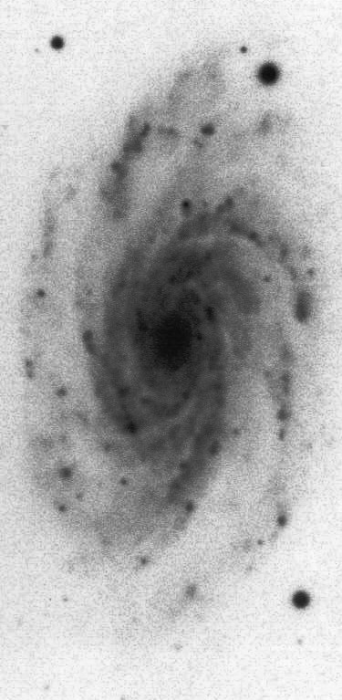NGC 7083
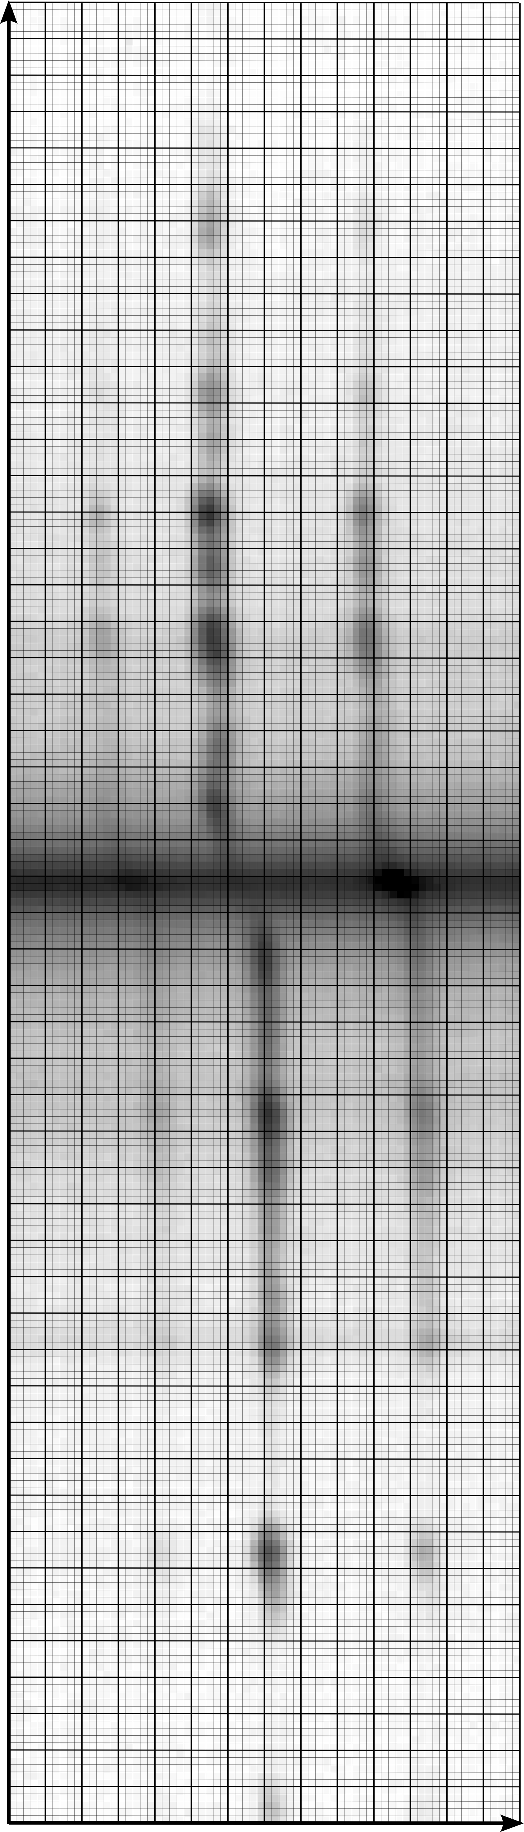Spectrum of NGC 7083

