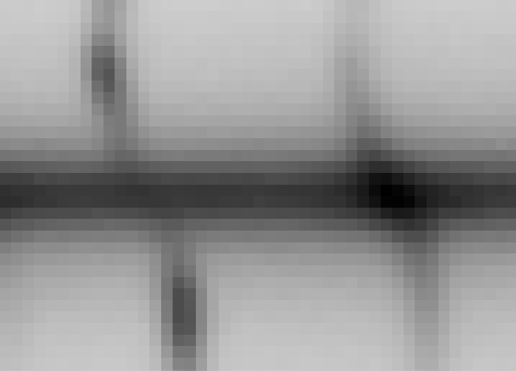

Solution:

Δλ= λ₁ - λ₂ = 20 Å
distance on picture =22 pixels ± 2 > horizontal scale 20/22= 0.9091 Å/pixel
Doppler shift from spectrum between uper and lower arm: Δλ = 7 pixels ± 1 = 6.3636 Å
2V_{radial} = c · Δλ/λ (c ≈ 300 000 km/s) = 290.8 km/s
Inclination problem: ( i – angle btrween line of view and galactic disc)
Size of galaxy image: a = 11.5 ± 0.5 cm, b = 6.5 ± 0.5 cm > i=arc sin (b/a) ≈ 35º
cos (i) = V_{radial} / V_{rotation} > V_{rotation} = V_{radial}/2cos(35) = 216.7 km/s

Mass determinarion:
From Kepler’s law: M = V² · R / G
R ≈10 pixel = 1580pc·3.09·10¹⁶ m/pc = 4.88·10¹⁹
M= 3.4 · 10⁴⁰ kg > 1.7·10¹⁰ M (M ≈2·10³⁰ kg)

