Observing competition – night round
Instructions
- There are 2 questions, each worth 25 points. You have 80 minutes to solve them, of which :
- 25 minutes for reading the question and preparing for the observations,
- 30 minutes to perform all the observations at the telescope
(for both questions),
- 25 minutes for calculations and finishing your work.
- Additional time is allowed to move to and from the observing site.
- Along with the questions you will receive a map of the sky, for use with both questions.
- At the observing site you will find ready :
- a refracting telescope with a right-angle mirror and an eyepiece with an illuminated reticle, which can be rotated about the optical axis,
- a red torch, stopwatch, pencil, eraser and clipboard,
- a chair.
Note: the telscope is already aligned – do not change the position of the tripod!
The brightness of the reticle can be adjusted by turning the on-off switch.
- You are allowed to take only the questions, answer sheet and blank paper for additional work with you to the telescope.
- Only the answer sheet will be assessed. The additional worksheets will not be assessed.
- Clearly mark every page of the answer sheet with your code number.
- If you have difficulty with the equipment (not related to the question) or disturb the alignment of the telescope, call an assistant.
Observing competition – night round
- The Little Dolphin
An asterism known as the Little Dolphin lies near a line connecting the stars α Peg (Markab) and β Peg (Scheat). It is marked with a cicle on the large-scale map.
The map also shows the constellation of Delfinus, the Dolphin, with the brightest stars labelled with their Bayer designations (α, β, γ, δ and ε).
The coordinates of α and β Peg and the Little Dolphin (in right ascension order) are:
 | Right Ascension  α | Declination  δ
Little Dolphin | 23 ^{h} 02 ^{m} | +23.0 º
β Peg | 23 ^{h} 04 ^{m} | +28.1 º
α Peg | 23 ^{h} 05 ^{m} | +15.2 º

Based on your observations, make two drawings on the answer sheet :
On Drawing 1 :
Draw the view of the constellation Delphinus (Del) as seen through the finder scope. Include as many stars as you can see in the field of view.
With an arrow, mark the apparent direction of motion of the stars across the field of view of the finder scope caused by the rotation of the Earth.
Label the stars with the Bayer designations given on the map (α, β, γ, δ and ε).
Also label the brightest of these 5 stars “m_{max}”.
Also label the faintest of these 5 stars “m_{min}”.

On Drawing 2 :
Draw the view of the Little Dolphin as seen through the larger telescope. Include as many stars as you can see in the field of view.
With an arrow, mark the apparent direction of motion of the stars across the field of view of the telescope caused by the rotation of the Earth.
Label the stars of the Little Dolphin α′, β′, γ′, δ′ and ε′ such that they match the labels of the stars in the constellation Delphinus as given on the map.
Label the brightest of these 5 stars “m_{max}”.
- Determining declination
The two pictures on the next page show a small asterism, as seen directly on the sky and as a mirror image. Three stars are labelled: S1, S2 and Sx. The position of the asterism is also marked with a rectangle on the larger-scale map of the sky.
Find this asterism and point your telescope to it.
Using the illuminated reticle as a fixed reference point, and the stopwatch, measure the time taken for the stars S1, S2 and Sx to move across the field. You may rotate the eyepiece so that the cross-hairs of the reticle are in the most convenient position for your measurement.
Use your measurements and the known declinations of stars S1 and S2 as given below to determine the declination of star Sx.
On the answer sheet, give your measurements and working, and estimate the random error in your result.
For each set of measurements you make, draw the view through the eyepiece on the answer sheet. (Use the blank circular field on the answer sheet.)
Mark the drawing with the compass directions N and E. Draw the reticle and the tracks of the stars to show the motion which you timed using the stopwatch.
Mark the ends of each timed track and show which time measurement refers to which track – for example, for measurement “T1” marking the ends “Start T1” and “End T1”.
The angle of the reticle can be easily adjusted by rotating the eyepiece around its optical axis. If you change the angle of the reticle for a new measurement, draw a new diagram.
The declinations of the field stars S1 and S2 are :
S₁ : δ = +19 º 48′ 18″ S₂ : δ = +20 º 06′ 10″
Assume that: δ (S₂) > δ (Sx) > δ (S₁).

Direct view:

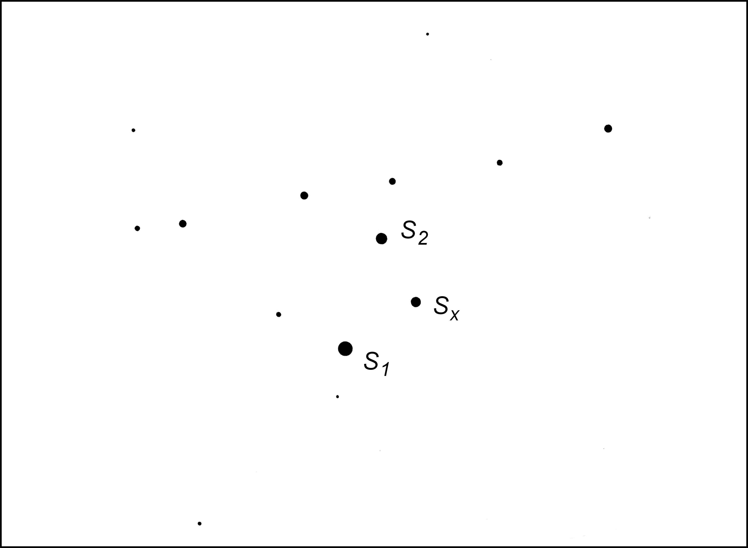
Mirror image:
