Observing problems:

- Please point telescope to 21/P Giacobini-Zinner comet, and draw what you see in telescope (comet and background stars). Mark directions of N and E no yours picture.
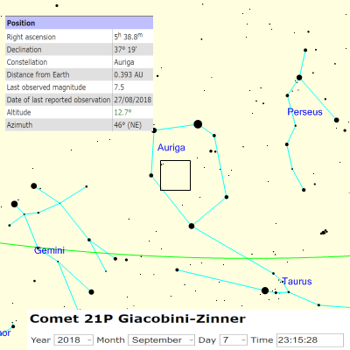

Points:

Point telescope to comet 10p
Draw image (comet and stars ) 10p
Mark the N and E directions on the image 5p
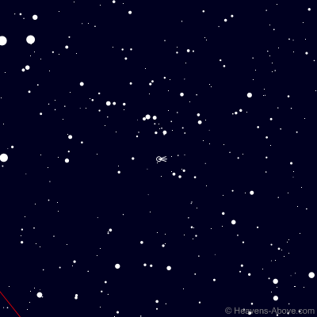

2) Saturn observation:
- Please point telescope to Saturn
- Draw image of the field of view with accurate proportions of Saturn and ring sizes
- If you can see it, please mark the ring gaps, Saturn’s shadow on the ring, the ring shadow on Saturn
- Mark positions of background stars and Saturn’s moons
- Mark the N and E directions on the image
- Estimate the inclination of ring plane to the direction to the observer
- Estimate the angular size of Saturn and calculate its linear size.
(for Saturn’s orbit a = 9.5 AU)

Points:
Point telescope to Saturn 5p
Draw image 5p
Mark the N and E directions on the image 5p
Estimate the inclination of ring plane to the direction to the observer 5p
Estimate the angular size 36” of Saturn and calculate its linear size. 5p

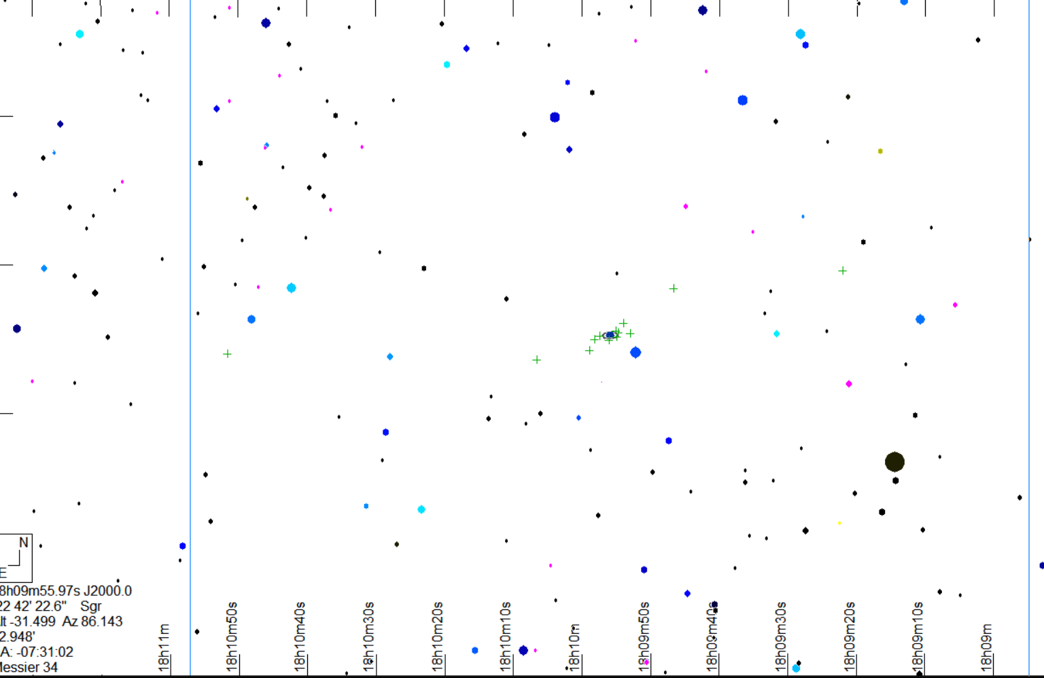
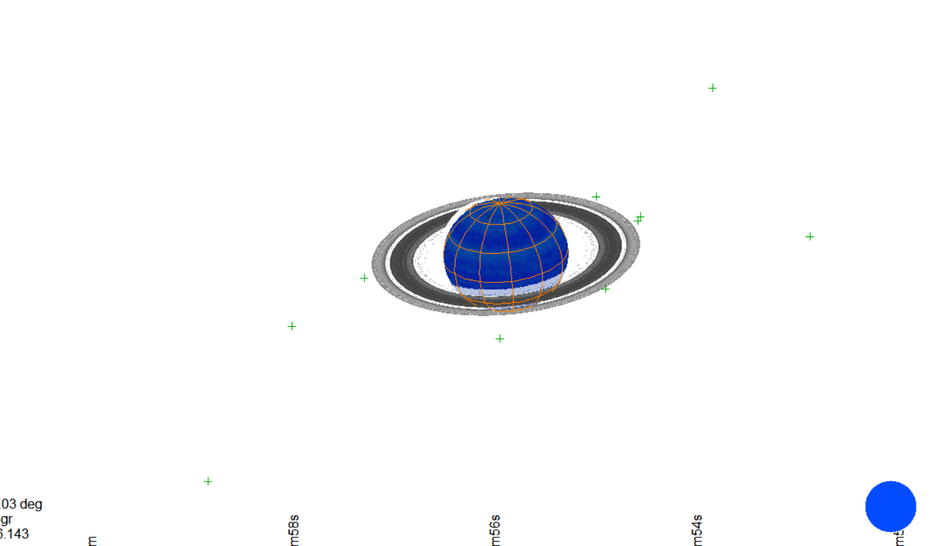

- Double star observation

- Point telescope to Albireo, draw the telescope view. The Position angle of components (measured from N) is 56° and separation is 34”
- Do the same picture for one of star from the table below
- Based on your drawings, estimate the position angle and angular distance between components

Star: | α  h m | δ  ° ’ | Mag  A+B | Mag^{A} | Mag^{B}
ζ Psc AB | 1 13.7 | +7 35 | 4.8 | 5.2 | 6.2
γ Ari AB | 1 53.5 | +19 18 | 3.8 | 3.9 | 3.9
κ Her AB | 16 08.1 | +17 03 | 4.8 | 5.1 | 6.2
16 Cyg Aa-B | 19 41.8 | +50 32 | 5.3 | 6.0 | 6.2
δ Cep AC | 22 29.2 | +58 25 | 4.0 | 4.1 | 6.3

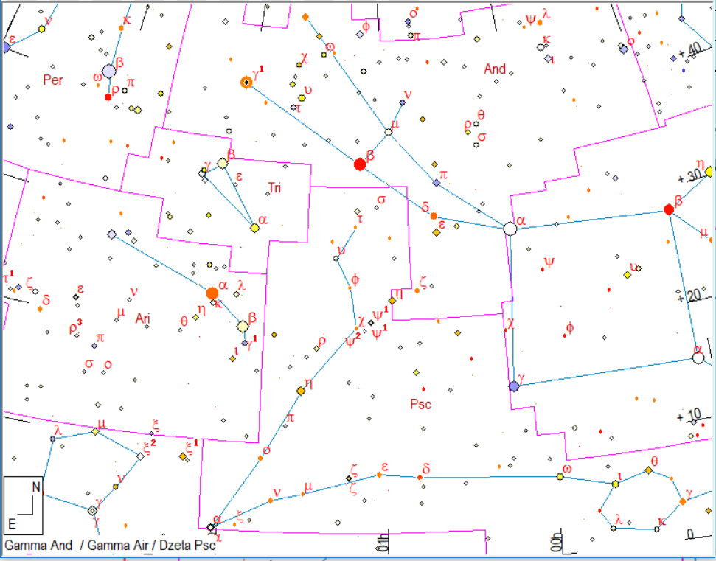
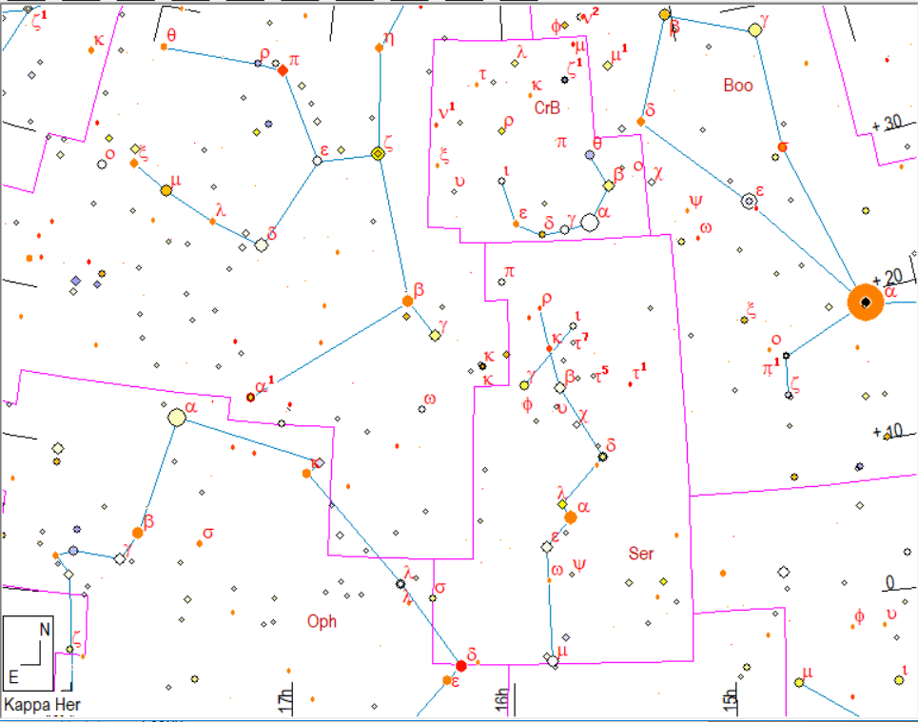
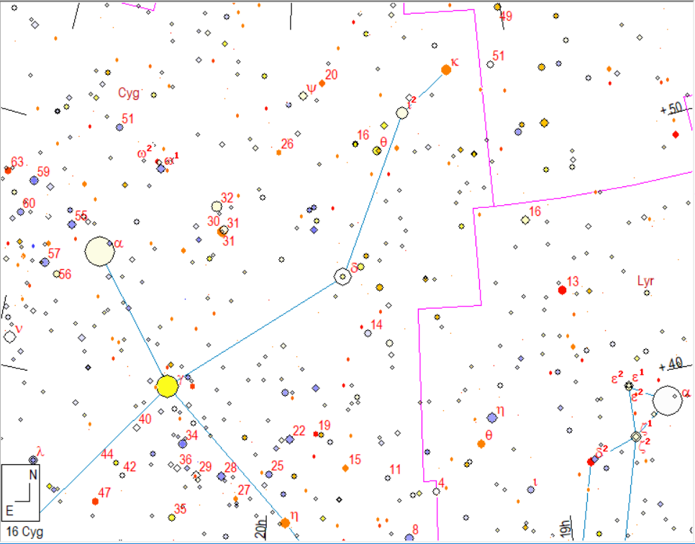

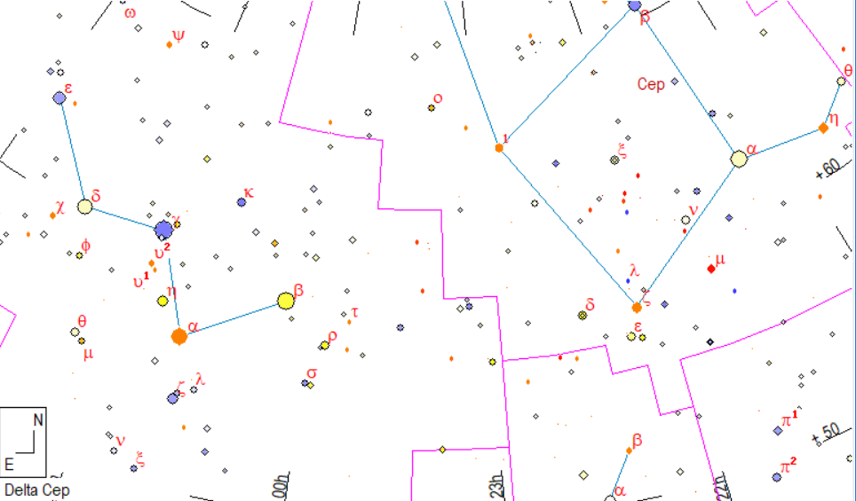
Points:
Pointing and draw of Albireo with correct N E directions 5p
Star pointing 10p
Picture and correct estimation 10p
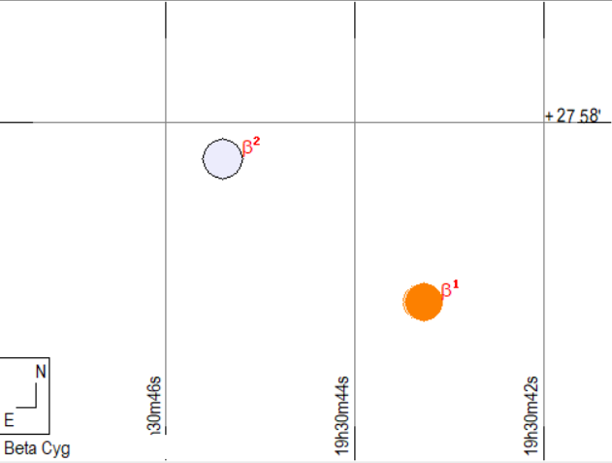
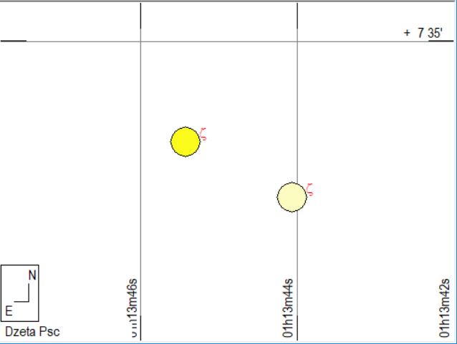

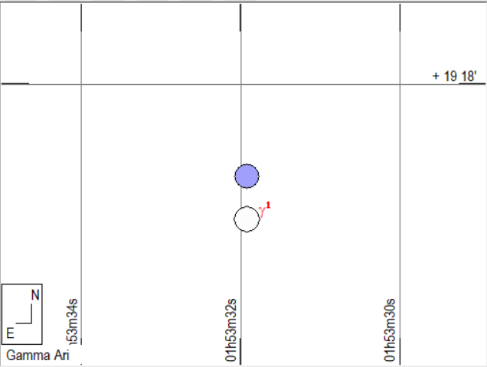
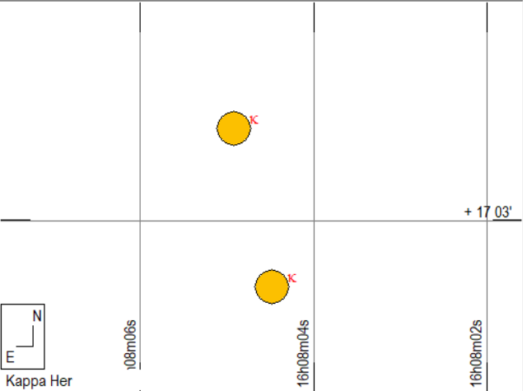
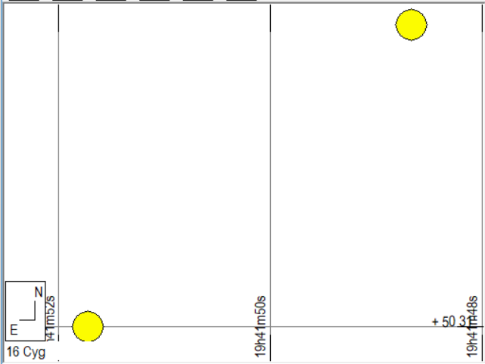
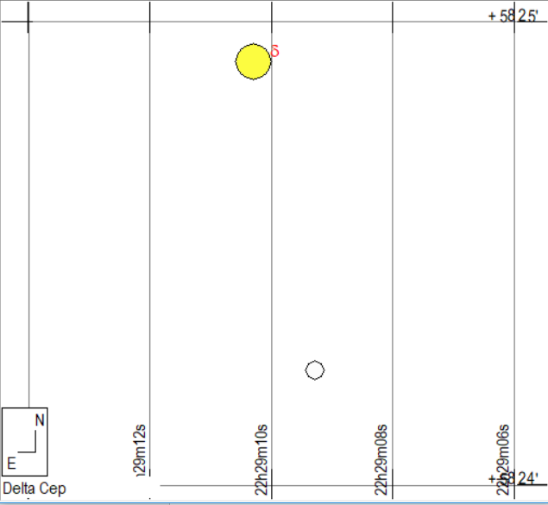

- Mars-Saturn

Estimate an angular distance between Saturn and Mars. You can use a telescope’s Hour Angle and Declination scales.

Pointing to Planets and coordinates determination 5p
Calculation of distance using spherical trinagle 10p
(or flat triangle !! if students give remarks that error will be small )

Alternative method:
It is possible to change ϕ of telescope and make telescope equator parallel to ecliptic 10p

4) Sun observation (Necessary: clock, 2 pencils, ruler, protractor)
Please, draw the shadow of vertical stick (pencil) on a paper and record an exact time of observation. Calculate and mark S-N directions on your picture.
Time equation R= 0 min. GPS coordinates of observing place: : N 46.882417 E 17.708329

Points:
Correct estimation of solar true time and hour angle of true Sun 10p
Solving spherical triangle to calculate current azimuth 15p
(it is easy if students estimate altitude of Sun from length of shadow,
And assumption that Dec = +10° )

5) Sun observations on screen. Determine a angular size of sun by measuring the size of image. Please remember to check focal a focal length of telescope and eyepiece

Points:
Proper measuring and calculations 5p
error estimation 5+5p

